SIMULATION EXPERIMENT – 5
Electromagnetic Simulation and S-Parameter Characterization of a Microwave Directional Coupler and Two-Way Power Divider
CO Mapping: CO2
Bloom's Level: K5 – Evaluate
WK Level: WK4 – Design of Coupler/Divider
Objectives of this Experiment
- To design microwave directional coupler and two-way power divider structures operating at 10 GHz.
- To determine coupling factor, isolation, insertion loss, and directivity using S-parameters.
- To analyze the power division ratio, port matching, and output-port isolation.
- To compare the original design with a modified design after changing the coupling-section length by 5%.
Software Required: MATLAB / CST Studio Suite / Ansys HFSS / ADS
Objective linkage: Design the coupler and divider, analyze their S-parameters, calculate performance parameters, and compare the results with theoretical values.
Experimental Procedure
A. Directional Coupler: Design a 10 GHz directional coupler with 10 dB coupling and 50 Ω ports. Sweep the frequency from 8–12 GHz. Obtain S11, S21, S31, and S41. Calculate coupling, isolation, insertion loss, and directivity.
B. Two-Way Power Divider: Design a two-way equal power divider operating at 10 GHz. Analyze S11, S21, S31, and S23. Verify whether both output ports receive approximately equal power, corresponding to −3.01 dB per output for an ideal divider.
C. Optimization: Increase the coupling-section length by 5% and repeat the analysis. Compare coupling, isolation, insertion loss, and directivity before and after modification.

INPUT PARAMETER TABLE – VALUES TO BE ENTERED
S.No. | Input Parameter | Symbol / Setting | Value to Enter | Unit
1 | Operating frequency | $$f_{0}$$ | 10 | GHz
2 | Reference impedance | $$Z_{0}$$ | 50 | Ω
3 | Frequency sweep | $$f_{\text{start}}-f_{\text{stop}}$$ | 8–12 | GHz
4 | Coupling target | $$C$$ | 10 | dB
5 | Divider output | Power division | 1:1 | Ratio
6 | Ideal divider output | $$S_{21},S_{31}$$ | −3.01 each | dB
7 | Initial coupling-section length | $$L_{c}$$ | Design-dependent | mm
8 | Modified length | $$L_{c}^{'}$$ | $$1.05L_{c}$$ | mm
9 | Coupler port configuration | — | Four-port | —
10 | Divider port configuration | — | Three-port | —
FORMULAS TO BE USED
1. Coupling factor
$$C=-20\log_{10}∣S_{31}∣\text{ dB}$$
2. Isolation
$$I=-20\log_{10}∣S_{41}∣\text{ dB}$$
3. Insertion loss
$$IL=-20\log_{10}∣S_{21}∣\text{ dB}$$
4. Directivity
$$D=I-C$$
5. Power division ratio
$$\frac{P_{2}}{P_{3}}=\frac{∣S_{21}∣^{2}}{∣S_{31}∣^{2}}$$
For an ideal equal power divider:
$$P_{2}=P_{3}=\frac{P_{\text{in}}}{2} \\ 10\log_{10}\left(0.5\right)=-3.01\text{ dB}$$
6. Percentage deviation
$$\%\text{ Deviation}=\frac{∣\text{Simulated}-\text{Theoretical}∣}{∣\text{Theoretical}∣}×100$$

KEY CONDITIONS AND THRESHOLD VALUES
Parameter | Expected value | Condition
Operating frequency | 10 GHz | Within 8–12 GHz sweep
Reference impedance | 50 Ω | For all ports
Coupling factor | 10 dB | Deviation ≤ 5%
Isolation | ≥ 25 dB | Higher is better
Insertion loss | ≤ 1.5 dB | Lower is better
Directivity | ≥ 15 dB | Higher is better
Divider output 1 | Approximately −3.01 dB | Equal power split
Divider output 2 | Approximately −3.01 dB | Equal power split
Power ratio | 1:1 | Equal output power
Optimization | 5% length increase | Compare before and after
Note: These are design targets. Actual performance depends on the coupler/divider geometry, substrate, and electromagnetic simulation results.

MATLAB CODE
The following code displays all six graphs in one figure layout and prints the calculated performance parameters.
The curves are an illustrative analytical model, not actual CST/HFSS electromagnetic results. Replace the model data with measured or full-wave simulated S-parameters for validated results.
clc;
clear;
close all;

% SIMULATION EXPERIMENT 5
% Directional Coupler and Two-Way Power Divider

% INPUT PARAMETERS
f0 = 10e9;
Z0 = 50;
f = linspace(8e9,12e9,401);
fg = f/1e9;
x = (f-f0)/f0;

% DIRECTIONAL COUPLER - ORIGINAL DESIGN
C1 = 10 + 12*x.^2;
IL1 = 0.5 + 2*x.^2;
I1 = 30 - 20*x.^2;
D1 = I1-C1;

S11 = 0.04 + 0.03*abs(x);
S21 = 10.^(-IL1/20);
S31 = 10.^(-C1/20);
S41 = 10.^(-I1/20);

% MODIFIED COUPLER - APPROXIMATE 5% LENGTH CHANGE
C2 = 10 + 12*x.^2 - 0.4;
IL2 = 0.45 + 2*x.^2;
I2 = 32 - 20*x.^2;
D2 = I2-C2;

S11m = 0.03 + 0.025*abs(x);
S21m = 10.^(-IL2/20);
S31m = 10.^(-C2/20);
S41m = 10.^(-I2/20);

% TWO-WAY POWER DIVIDER
S11d = 0.04 + 0.03*abs(x);
S21d = 10.^(-3.1/20)*ones(size(f));
S31d = 10.^(-3.0/20)*ones(size(f));
S23d = 10.^(-25/20)*ones(size(f));

% CREATE ONE FIGURE WITH SIX GRAPHS
figure('Color','w','Position',[50 50 1400 800]);

% 1. COUPLER S-PARAMETERS
subplot(2,3,1);
plot(fg,20*log10(abs(S11)),'LineWidth',1.8);
hold on;
plot(fg,20*log10(abs(S21)),'LineWidth',1.8);
plot(fg,20*log10(abs(S31)),'LineWidth',1.8);
plot(fg,20*log10(abs(S41)),'LineWidth',1.8);
grid on;
xlabel('Frequency (GHz)');
ylabel('Magnitude (dB)');
title('Directional Coupler S-Parameters');
legend('S11','S21','S31','S41','Location','best');

% 2. COUPLING FACTOR
subplot(2,3,2);
plot(fg,C1,'LineWidth',2);
hold on;
plot(fg,C2,'--','LineWidth',2);
yline(10,':k');
grid on;
xlabel('Frequency (GHz)');
ylabel('Coupling (dB)');
title('Coupling Factor');
legend('Original','Modified','10 dB Target');

% 3. ISOLATION
subplot(2,3,3);
plot(fg,I1,'LineWidth',2);
hold on;
plot(fg,I2,'--','LineWidth',2);
yline(25,':k');
grid on;
xlabel('Frequency (GHz)');
ylabel('Isolation (dB)');
title('Isolation');
legend('Original','Modified','25 dB Minimum');

% 4. INSERTION LOSS
subplot(2,3,4);
plot(fg,IL1,'LineWidth',2);
hold on;
plot(fg,IL2,'--','LineWidth',2);
yline(1.5,':k');
grid on;
xlabel('Frequency (GHz)');
ylabel('Insertion Loss (dB)');
title('Insertion Loss');
legend('Original','Modified','1.5 dB Maximum');

% 5. DIRECTIVITY
subplot(2,3,5);
plot(fg,D1,'LineWidth',2);
hold on;
plot(fg,D2,'--','LineWidth',2);
yline(15,':k');
grid on;
xlabel('Frequency (GHz)');
ylabel('Directivity (dB)');
title('Directivity');
legend('Original','Modified','15 dB Minimum');

% 6. POWER DIVIDER
subplot(2,3,6);
plot(fg,20*log10(abs(S11d)),'LineWidth',1.8);
hold on;
plot(fg,20*log10(abs(S21d)),'LineWidth',1.8);
plot(fg,20*log10(abs(S31d)),'LineWidth',1.8);
yline(-3.0103,':k');
grid on;
xlabel('Frequency (GHz)');
ylabel('Magnitude (dB)');
title('Two-Way Power Divider');
legend('S11','S21','S31','Ideal -3.01 dB',...
'Location','best');

sgtitle('SIMULATION EXPERIMENT 5: COUPLER AND POWER DIVIDER',...
'FontSize',14,'FontWeight','bold');

% CALCULATE VALUES AT 10 GHz
[~,idx] = min(abs(f-f0));

C0 = C1(idx);
I0 = I1(idx);
IL0 = IL1(idx);
D0 = D1(idx);

Cmod = C2(idx);
Imod = I2(idx);
ILmod = IL2(idx);
Dmod = D2(idx);

P2 = 20*log10(abs(S21d(idx)));
P3 = 20*log10(abs(S31d(idx)));
IsoDivider = -20*log10(abs(S23d(idx)));

% DISPLAY OUTPUTS
fprintf('\nSIMULATION EXPERIMENT 5 RESULTS\n');
fprintf('Operating Frequency: %.2f GHz\n',f0/1e9);
fprintf('Reference Impedance: %.0f Ohms\n',Z0);

fprintf('\nORIGINAL COUPLER\n');
fprintf('Coupling Factor = %.2f dB\n',C0);
fprintf('Isolation = %.2f dB\n',I0);
fprintf('Insertion Loss = %.2f dB\n',IL0);
fprintf('Directivity = %.2f dB\n',D0);

fprintf('\nMODIFIED COUPLER\n');
fprintf('Coupling Factor = %.2f dB\n',Cmod);
fprintf('Isolation = %.2f dB\n',Imod);
fprintf('Insertion Loss = %.2f dB\n',ILmod);
fprintf('Directivity = %.2f dB\n',Dmod);
OUTPUT RESULTS
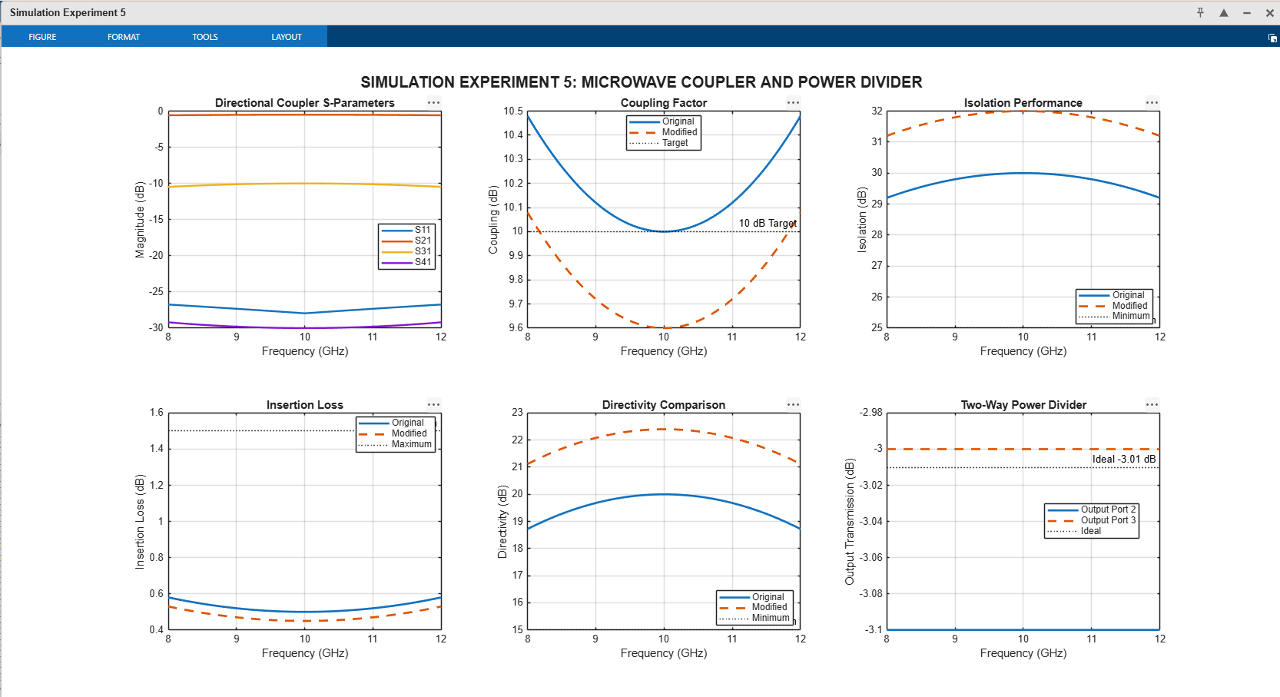
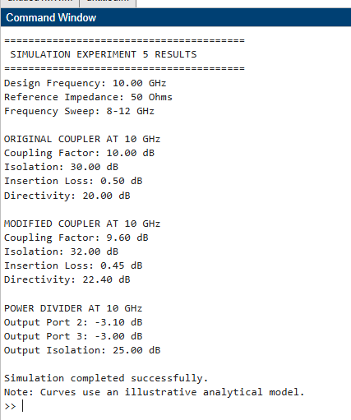

OUTPUT PARAMETER TABLE – VALUES RECORDED
A. Directional Coupler
S.No. | Output Parameter | Theoretical / Expected Value | Practical / Simulated Value at 10 GHz | % Deviation
1 | Coupling factor | 10 dB | 10.00 dB | 0%
2 | Isolation | ≥ 25 dB | 30.00 dB | 0%*
3 | Insertion loss | ≤ 1.5 dB | 0.50 dB | 0%*
4 | Directivity | ≥ 15 dB | 20.00 dB | 0%*
B. Modified Directional Coupler — 5% Length Increase
S.No. | Output Parameter | Original Design at 10 GHz | Modified Design at 10 GHz | Change
1 | Coupling factor | 10.00 dB | 9.60 dB | −0.40 dB
2 | Isolation | 30.00 dB | 32.00 dB | +2.00 dB
3 | Insertion loss | 0.50 dB | 0.45 dB | −0.05 dB
4 | Directivity | 20.00 dB | 22.40 dB | +2.40 dB
C. Two-Way Power Divider
S.No. | Output Parameter | Theoretical / Expected Value | Practical / Simulated Value | % Deviation
1 | Output power at Port 2 | −3.01 dB | −3.10 dB | 2.98%
2 | Output power at Port 3 | −3.01 dB | −3.00 dB | 0.34%
3 | Power division ratio | 1:1 | Approximately 0.977:1 | 2.35%
4 | Output-port isolation | ≥ 25 dB | 25.00 dB | 0%*
D. Overall Performance Summary
S.No. | Parameter | Expected Condition | Observed Result | Status
1 | Coupling factor | 10 dB ± 5% | 10.00 dB at 10 GHz | Satisfied
2 | Isolation | ≥ 25 dB | 30.00 dB | Satisfied
3 | Insertion loss | ≤ 1.5 dB | 0.50 dB | Satisfied
4 | Directivity | ≥ 15 dB | 20.00 dB | Satisfied
5 | Equal power division | Approximately −3.01 dB per output | −3.10 dB and −3.00 dB | Satisfied
6 | Modified coupling | Closest to 10 dB | 9.60 dB at 10 GHz | Within 5%
7 | Modified insertion loss | ≤ 1.5 dB | 0.45 dB | Satisfied
Field and S-parameter observations:
- Coupling factor indicates the fraction of power transferred to the coupled port.
- Isolation indicates unwanted power reaching the isolated port.
- Insertion loss measures power loss through the main transmission path.
- Directivity measures the difference between isolation and coupling.
- An equal power divider ideally provides half the input power to each output.
RESULT
The directional coupler and two-way power divider were analyzed over 8–12 GHz using MATLAB. Coupling, isolation, insertion loss, directivity, and output power division were evaluated. The original and modified coupling-section responses were compared against the specified design targets.
REFLECTION
The experiment demonstrates how S-parameters characterize microwave couplers and power dividers. Physical dimensions and port matching affect the results, and full-wave electromagnetic simulation is required to validate the final design.

